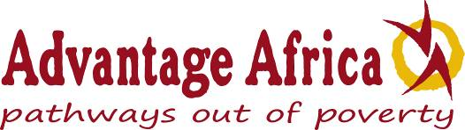

**Report on Exchange Visit / Study Tour – Bridging the Gap between Disability Research and Practice, East Africa**

*May 2016*

**Context**

FIRAH and Advantage Africa have been working together to explore the issues concerning the perceived gap between applied disability research findings and the application of those findings for the ultimate benefit of persons with disabilities. As part of this work we organised a workshop and study tour in Uganda in early March 2016. Prior to this Advantage Africa had produced a short discussion paper *Bridging the Gap Between Applied Disability Research and the Application of Research Findings to Benefit Persons with Disabilities***1** and *A Conceptual Pyramid Showing the Interactions Between Research Institutions and Associated Stakeholder Groups***2**

**Workshop Aim**

The aim of workshop was to bring together researchers from universities / research institutions**3** with field stakeholders**4** to investigate the connections and / or disconnections between applied disability research and its practical application to change practice and policy for the benefit of persons with disabilities.

Sixteen participants attended the workshop representing both research institutions and field stakeholders which have practical experience of responding to the needs of persons with disabilities at community level. Six of the participants were persons with disabilities. Five participants were from Kenya, nine from Uganda and two from UK (see appendix 1 for participants list).

**1** [http://www.advantageafrica.org/file/discussion-paper-on-the-gap-between-research-and-practice-pdf](http://www.advantageafrica.org/file/discussion-paper-on-the-gap-between-research-and-practice-pdf%20)

**2** <http://www.advantageafrica.org/file/conceptual-pyramid-pdf>

**3Research institutions and Researchers - FIRAH definition**   
An entity, such as a university or a research institute, or a department dedicated to research within an institution, or developed by a group of institutions and affiliated with a university or a research institute, regardless of its legal status (public or private body) or the way it is funded, whose primary purpose is to carry out basic research or applied research or experimental development and to broadcast their findings by way of teaching, publication or technology transfer.

**4Field stakeholders - FIRAH definition**  
Persons with disabilities, their families, and their representative organisations. Any Human Rights organisation working with persons with disabilities. Service providers and other organisations working with Persons with disabilities. Service providers and other organisations working in mainstream that are required to meet the needs of persons with disabilities such as architects, teachers, companies, industries etc. Local, national and international decision makers.

**Workshop Outputs**

The outputs produced from the workshop were:

1. A short paper of guidelines on how to create ‘means of application’ from applied disability research. This includes analysis of the existing barriers and ways of working, recommendations on how research topics are selected, the make-up of research teams (how to include stakeholders etc.) and the media that is used to disseminate findings and convert findings into practical concrete applications.

2. A set of concept ideas for potential future ‘means of application’ based on research that the participants knew about or had been directly involved in (pending submission to FIRAH).

**Activities**

**The study visit to Comprehensive Rehabilitation Services in Uganda (CoRSU).**

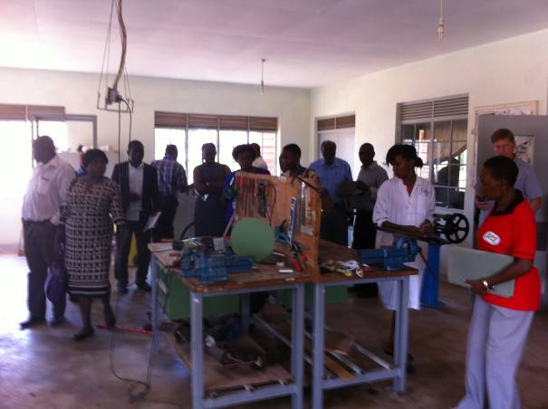This visittook place on 1st March and on the following day the workshop was hosted by the Faculty of Special Needs and Rehabilitation, Kyambogo University, Kampala.The purpose of the visit to CoRSU was to see how a collaboration between applied research at Toronto University in Canada and a medical institution in Uganda is developing a new way of providing prosthetic rehabilitation services. It was also explained that the project also includes a partnership with a Canadian social enterprise called Nia Technologies Inc. (<http://niatech.org/>). The study tour participants were reminded that this was a medical example of taking research into practice, and that their task in the workshop the following day would be to also explore how other areas of disability research, including social, economic or policy issues can be developed into ‘means of application’**5**. The study group where shown around the orthopaedic workshop (right) where conventional prostheses are made and fitted along with the new testing of 3D printed prosthetic parts. The problem addressed by this new research collaboration is that there are huge numbers of amputees in developing countries who have little or no access to prosthetic rehabilitation. This is because the number of orthopaedic services and technicians is completely inadequate and to train sufficient technicians is unlikely to ever be achieved. Therefore an alternative, faster and cheaper means of making prostheses can potentially have significant positive impact. We were shown how the new technology works, starting with a digital scan of the patient’s limb to create a digital 3D model on the computer. The model is then finely adjusted by the

**5** Applied research results and knowledge, to facilitate their practical application in the field (FIRAH Definition).

technician to suit the specific needs of the patient and then created as a physical product by printing in plastic on a 3D printer.

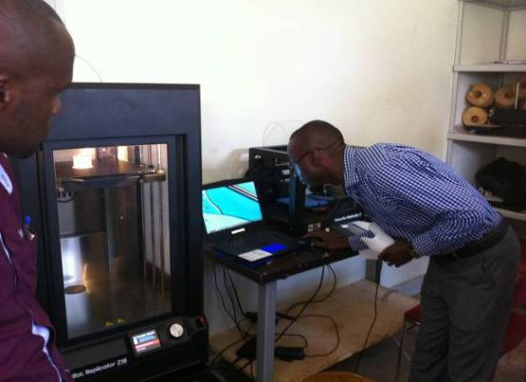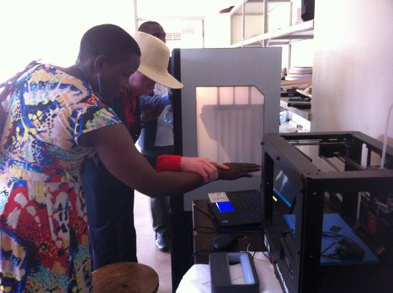

**Demonstration of the 3D scanning & printing technology**

**Blind participants exploring the process**

We observed that this research project was devised to solve a clear problem, and the research process and collaborations between organisations were developed in order to achieve a practical outcome. The more difficult question is how research in areas like social and economic issues can also be designed with ‘means of application’ central to the outcomes.

**The workshop** was held at Faculty of Special Needs and Rehabilitation, Kyambogo University on 2nd March 2016. The programme for the day was designed to achieve the outputs stated above (see programme Appendix 2). Two examples of current research were presented which illustrated how research might be designed and conducted to produce findings which can be developed into ‘means of application’. Participant discussions took place in groups to consider firstly if the application of disability research is important, and if so, how it can be achieved.

The general consensus of the group, and notably amongst the academic participants, was that most research does not actually make a significant difference to the lives of persons with disabilities that are the subject group of the study. The reasons for this were carefully considered and identified and are detailed in the guidelines document which forms the main output of the workshop. The notes taken during the workshop are detailed in appendix 2.

**Workshop discussion groups**

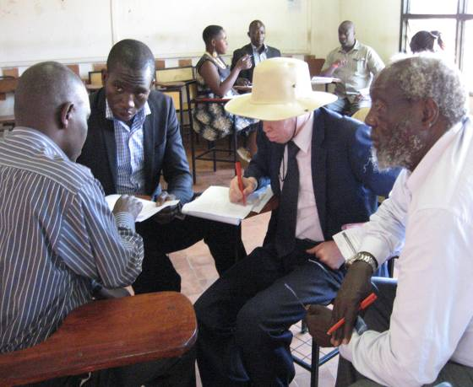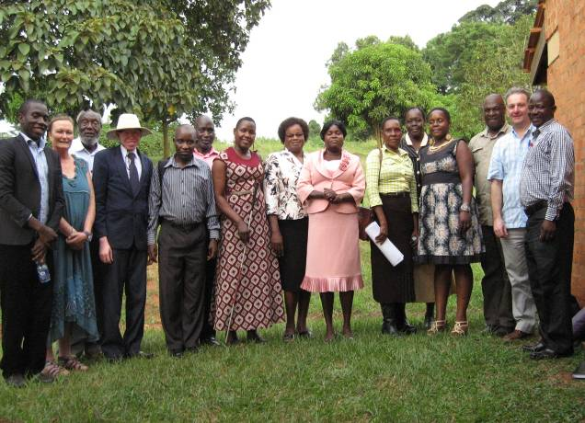

**Workshop participants**

Appendix 1 – Participants List

*Note – two of the original invitees were unable to attend*

|  |  |  |  |  |
| --- | --- | --- | --- | --- |
|  |  | **Researcher / DPO representatives** | **University / Organisation** | **Research they have undertaken** |
| RESEARCHERS | 1 | Carolyne Maholo.  Senior Lecturer | Faculty of Special Needs and Rehabilitation, Kyambogo University,  Kampala | Linking CBR, Disability and Rehabilitation  Musoke and Geiser (2013)  Chapter by Carolyne Maholo |
| 2 | Ephraim Lemmy Nuwagaba.  Research Fellow | Faculty of Special Needs and Rehabilitation, Kyambogo University,  Kampala | 1. Navigating the ethical maze in disability research: ethical contestations in an African context (2015)  2. Accessibility to micro-finance services by people with disabilities in Bushenyi District, Uganda (2012)  (note these papers are not currently in the mapping but could be added) |
| 3 | Dr. Franciscah Irangi  Wamocho,  Senior Lecturer | Dept. Special Education  Kenyatta University,  Nairobi | Development of a guidance programme for students with special educational needs in Kenya: a study on personal orientation (2008) |
| 4 | Prof. G Karugu | Professor of Special Education  Kenyatta University,  Nairobi | Development of Guidance Programme for Students with Special Educational Needs (2008), British Journal of Special Education, Vol. 35 |
| 5 | Marilyn Apella,  Senior Lecturer | School of Design and Architecture, Maseno University, Western Kenya | Accessibility of Students With  Physical Disability to Washrooms in Bungoma Main Bus Terminus  (2013). Accepted by  Disability, CBR and Inclusive Journal |
| 6 | Dr Victor Locoro | Faculty of Special Needs and Rehabilitation, Kyambogo, University,  Kampala | Linking CBR, Disability and Rehabilitation  Musoke and Geiser (2013)  Chapter by Victor Locoro |
| 7 | Dr. Eria Paul Njuki | Head of Department Community and Disability Studies, Kyambogo University, Kampala | Parents’ Perception of the Goal of  Education for Their Children With  Learning Difficulties (2008).  Community Action Research on Disability in Uganda |

|  |  |  |  |  |
| --- | --- | --- | --- | --- |
| DISABLED PERSONS’ ORGANISATIONS  (Community Stakeholders) | 8 | Agnes Musembi, Coordinator  (Person with a disability) | Kibwezi Disabled Persons Organisation (KDPO) Kenya | Advantage Africa current research  An Assessment of the Social, Cultural and Institutional Factors that Contribute to the Sexual Abuse of Persons with Disabilities in East Africa. |
| 9 | David Kariuki, Physiotherapist and CBR consultant | Kibwezi Disabled Persons Organisation (KDPO) Kenya | Advantage Africa current research  An Assessment of the Social, Cultural and Institutional Factors that Contribute to the Sexual Abuse of Persons with Disabilities in East Africa. |
| 10 | Josephine Audri  Programme Manager | ADD International Uganda | Managing projects in disability and community action. |
| 11 | Esther Kyozira  (Person with a disability) | National Union of Disabled Persons of Uganda (NUDIPU) | Breaking the Silence: Violence against Children with Disabilities in Africa  (2010) |
| 12 | Fazira Kawuma, Coordinator  (Person with a disability) | Source of the Nile Union for Persons with Albinism (SNUPA) | Advantage Africa current research  An Assessment of the Social, Cultural and Institutional Factors that Contribute to the Sexual Abuse of Persons with Disabilities in East Africa. |
| 13 | Dr Mary Wickenden | Senior Research Fellow Centre for International Health and Development, University College London | [Widening the SLP lens: Responding more broadly to the World Report on Disability to improve the wellbeing of people with communication disabilities in the global south](https://iris.ucl.ac.uk/iris/publication/895105/1). (2013). International Journal of Speech-Language Pathology, 15 (1).  [An INGO’s participatory practice in informing CBR guidelines: Ghanaian and Ugandan experiences](https://iris.ucl.ac.uk/iris/publication/895106/1). (2012). African Journal of Disability. |
| 14 | Rob Aley | Programme Manager  Advantage Africa | An Assessment of the Social, Cultural and Institutional Factors that Contribute to the Sexual Abuse of Persons with Disabilities in East Africa. |
| 15 | Peter Ogik | Source of the Nile Union for Persons with Albinism (SNUPA) | An Investigation Into the Impact Of Stigma On the Education and Life Opportunities Available to Children and Young People With Albinism in Tanzania and Uganda - 2014 |
| 16 | Ronald Luyima (Uganda)  (Person with a disability) | Uganda Association of the Blind and Secondary School Teacher | Representing field stakeholders who are not usually involved in research |

Appendix 2 – Notes from workshop flip charts

**How are research topics and teams identified and chosen?**

**How are topics chosen?**

* Have to fit strategic direction of lead organisation
* Guidance from academic supervisors
* Should be based on Identification of a problem
* Should address a community need (but how do we find this out)
* Donor influences
* ‘Must be focused on a disability issue’

**How are research teams chosen?**

* They are professionals in the field
* Have experience in a related field
* Are persons with disabilities
* Through advertising for team members
* Word of mouth and networks
* Funders will want a strong team (which has budget implications)
* Availability of personnel

**What influence do academic institutions and funders have over research decisions?**

* Research is more ‘academic’ than ‘community’
* Academics will push their own interests
* Persons with disabilities may not believe that they can do research
* Academics can be ‘self-centred’ and want to progress their academic careers
* DPOs might struggle to articulate their needs (difficulty recognising how research can address their problems)
* Academic institutions might respond to a call for assistance from civil society groups like NGO’s / DPOs
* Applicants to funders might adjust their interests to match a donor’s requirements.
* NGOs, by the nature of their work, regularly make partnerships with community groups including disabled persons organisations. Academic institutions do not always make strong links with community level organisations.

**Recommendations concerning the influence of academic institutions and funders**

* Build capacity of DPOs to undertake and be involved in research (then they are more confident to lead).
* Stop academics being selfish – encourage them to ‘give away knowledge’. Academics should come out of their ‘know it all shells’
* Academic institutions should act as a catalyst or research facilitators in the research process, rather than research managers. This will help spearhead the capacity of the community to undertake their own research.
* There should be a balanced representation of stakeholders involved in the research.

**What partnerships and collaborations are made to undertake research (Are DPOs and PWDs involved in the research or in applying research findings)?**

* They often start from personal relationships and networks; these can develop into institutional collaborations.
* Most ideas actually come from Universities and INGOs not the community
* They can be between academics and DPOs which develop ideas together
* Mostly DPOs are involved after funding is secured
* Persons with disabilities are mostly involved in data collection (and analysis and dissemination).

Triple helix:

**

Research teams can incorporate an element of capacity building between research professionals but also between the professionals and those with little or no research qualifications or experience.

**Recommendations**

* Early involvement of all partners in the conceptualisation of the research
* Partnerships between organisations should be of equal value (equal status)
* Ensure that the team has multiple perspectives and includes multiple levels
* Ensure good communication between all organisations
* Team members should be mutually accountable
* There needs to be willingness to share, openness and trust
* There should be a clear delegation of roles
* Consider how different groups articulate themselves, and their use of language, concerning research issues.

**Emancipatory Research**

* A political approach linked to human rights
* Research which has a clear focus on improving, empowering, increasing participation
* Research which aims to change something
* Not the pursuit of pure knowledge
* Having a purpose - what is the route to the change? Be explicit about the route to change / pathways to impact.
* Expectations of the community about the outcome of the research.

**How are research findings usually disseminated – to which audiences and by which communication media?**

*The workshop participants acknowledged that they are usually not good at disseminating research beyond the usual academic audiences. This is an area where the gap between research and practice can be reduced.*

* There are usually academically / donor imposed dissemination obligations.
* Academic institutions do not always have effective dissemination structures. They often concentrate on academic requirements rather than wider dissemination to the groups that the research was studying and the general public

**Audiences**

*Note, increasingly a commitment to dissemination at all levels is required at research proposal stage.*

* Dissemination should be as wide as possible and to many audiences
* Academics to other academics and policy makers
* Donors, relevant bodies, institutions.
* Government – policy makers
* The General population
* Community level - women’s groups, faith organisations, disabled persons organisations

**Communication media**

* Publications- international, regional, national.
* Reports, research reports, peer reviewed journals, books.
* Policy briefs
* Seminars, workshops, conference presentations (international, regional, national.)
* 1-to-1 word of mouth
* Public media, local / national
* Public meetings
* Local presentations, plays, drama, skits
* Local meetings (take advantage of local meetings)
* Social media
* DVDs and CDs
* Accessible media, Sign language, Braille
* Newspapers, magazines, radio, TV in different languages
* Skits and drama- making use of the verbal / the story telling culture
* Illustrated versions - poster presentations
* Popular / simplified versions, summaries of findings etc
* All research team participants should be Acknowledged

Appendix 3, Workshop programme.

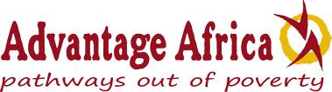  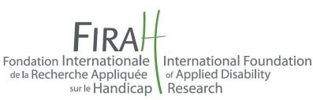

**Invitation**

**Bridging the Gap between Disability Research and Practice**

***Hosted by:* Advantage Africa and Kyambogo University - Faculty of Special Needs and Rehabilitation**

### *Venue:* Kyambogo University – Kampala, and visit to Comprehensive Rehabilitation Services in Uganda (CoRSU).

***Dates:* Tuesday 1st & Wednesday 2nd March 2016 (Arriving in Kampala 29th February**

**Kyambogo University Wed 2nd March from 9am to 4.30pm.**

* **9.00 -** **Welcome and introductions**
  + **9.20 –** **Plan for the day and topic overview** – A common understanding of the terms ‘applied (action) research’ and ‘means of application’ Rob Aley (Programme Manager - Advantage Africa).
  + **9.50 - Exploration of existing examples of applied research findings being put into practice (mini presentations – Rob Aley + others to be confirmed)**
  + **Morning tea - 11.00**
  + **11.20 - Analysis of the current practices and design of applied disability research.** 
    - How are research topics and teams identified and chosen?
    - What influence do academic institutions and funders have over research decisions?
    - What partnerships and collaborations are made to undertake research (Are DPOs and PWDs involved in the research or in applying research findings)?
    - How are research finding usually disseminated – to which audiences and by which communication media?
  + **12.00** **-** **Identification of recent or ongoing disability research which has good potential** for practical application to change practice and policy for the benefit of persons with disabilities. A proposed model of implementation.
  + **1pm Lunch**
  + **2pm - What factors can help ensure that applied research is not only aimed at developing new knowledge but also at improving the situation of persons with disabilities?** Interactive session in groups to generate a list of recommendations, facilitated by Dr Mary Wickenden

* + **3.15 – Afternoon tea**
  + **3.30 – Future ideas and collaborations*.*** for shaping of the findings and knowledge gained from applied research into products, services and contents to meet the expectations and needs of people with disabilities.With reference to FIRAH mapping
  + **4.30 –** **Summary of the day and concluding remarks – Evening meal together.**