Serious games and autism spectrum disorders
Documentary file

This documentary file was realised as part of the applied research project e-Goliah « e-Goliah » lead by Genious Systèmes in partnership with the CRAIF and the CHU Pitié-Salpêtrière.
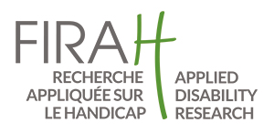
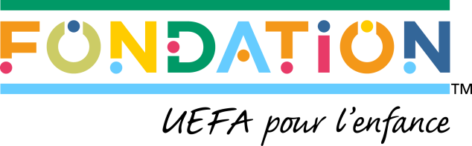

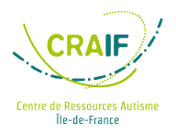
Presentation of the partners

Founded in 2009 and state-approved, FIRAH is a foundation entirely dedicated to applied disability research. The International Foundation of Applied Disability Research was created by: the APF France Handicap, the APAJH, Nexem and Axel Kahn (FIRAH’s President).

Our target is applied research which calls on a strong collaboration between stakeholders (including disabled people organisation) and researchers, in order to identify concrete solutions aimed at improving the quality of life of people with disabilities.

The UEFA Foundation for Children (https://uefafoundation.org/) was established on the initiative of the UEFA’s desire to play a more active role in society. The Foundation, which is a public body governed by Swiss law, was formally established and began operating the 24th of April 2015. For years, the governing body of European football has been supporting initiatives and programmes that help children in difficult circumstances, working with numerous different partners to develop projects across Europe and beyond. The foundation aims to help children and safeguard their rights. Sport, and football in particular, can provide support in the areas of health and children’s education, as well as promoting access to sporting activity, facilitating children’s personal development and fostering the integration of minorities.

The Foundation Orange is involved in three thematic: education, health and culture. Its objective is to fight exclusion of young people with academic difficulties or without qualifications, of women in precarious situation, and of autistic people. According to its activities, the Foundation Orange take an action to allow everyone to access digital technologies. It is present in 30 countries, with 8000 committed employees. More information: www.fondationorange.com

The Child and Adolescent Pyschiatry Unit (Service de Psychiatrie de l’Enfant et de l’Adolescent, SPEA PS) at the AP-HP, under the direction of Prof. Cohen, consists of a team of medical professionals highly specialised in treating autism, including a doctor responsible for the clinical division of the MICHELANGELO project, and 2 clinicians who have completed DENVER training.
The SPEA PS is affiliated with the Institute for Intelligent and Robotic Systems (Institut des Systèmes Intelligents et de Robotique, ISIR), the laboratory leading a major e-health project (labex SMART human/machine/human interactions in the digital society) and behind an health engineering institute in conjunction with the UPMC medicine faculty. SPEA team members are experts in developing, implementing and assessing imitation and joint attention psychological interventions for children with ASD, and generally specialists in development and psychopathology.

The GENIOUS group specialises in applying new technologies to serious games and other health-related therapeutic games. The GENIOUS R&D department has twenty professionals dedicated to e-health including specialists in digital pedagogy, game designers, graphic designers, multimedia developers, development engineers and a specialised 2D and 3D graphics team.
GENIOUS developed the Curapy.com platform, which is now an open access service that is free of charge to health professionals which offers clinically approved therapeutic video games.

CRAIF: a team of 15 professionals, including a clinical and social division that includes one doctor, three psychologists and two social workers that is focused on three strategic areas of interest:
1. Reducing inequality by developing new solutions to improve the lives of persons with autism and help them integrate in society.
2. Information, awareness and training by developing informative presentations, documentation and communication, notably in collaboration with local authorities. These actions are for the most part carried out in the context of the e-GOLIAH game dissemination and education project.
3. Research and innovation by promoting and contributing to action research.
The CRAIF relies on an extended partner network, and particularly on the national network of other Autism Resource Centres (Centre Ressources Autisme, CRA) as well as several child diagnostic centres and family associations. The CRAIF also created TAMIS, the 1st directory of autism resources for the Greater Paris area.

This document was drafted in the context of the "e-Goliah" applied research project led by Genious Systèmes, in partnership with CRAIF and the Child and Adolescent Psychiatry Unit of the CHU Pitié Salpêtrière. This research was funded under Theme 3 of the Autism and New Technologies programme supported by the UEFA Foundation for Childhood and the Orange Foundation.

The objective of this literature review is to assess current applied research knowledge of questions concerning the use of serious games for people with autism and to present several serious games.

This work does not intent to be comprehensive but to identify the results and knowledge generated by research that could be useful for field stakeholders in order to improve the quality of life and social participation for people with disabilities.

This document can be freely disseminated provided the source, author and relevant organisations are acknowledged.

FIRAH | 2019
Creative Commons Attribution – Non commercial – no derivatives 4.0 International.

Table of contents

Foreword 7
Synthesis of scientific knowledge 9
Autism, serious games and robotics: tangible reality or abuse of language? 9
Serious games to teach social interactions and emotions to individuals with autism spectrum disorders (ASD) 9
Serious games 11
COPYME 11
JESTIMULE 13
Let’s Face It ! 15
LifeIsGame (Learning Facial Emotions Using Serious Games) 17
MIND READING 19
SMILEMAZE 22

Foreword

This documentary file was compiled in the context of the "e-GOLIAH" project.

The purpose of this project was to provide children with ASD and their families with new and efficient technology-based rehabilitation solutions to improve social interactions within the family. By combining technology (tablets) and the ESDM programme (Early Start Denver Model), it has been possible to better respond to the social, developmental and emotional needs of children with ASD and their families.

Digital games have been developed using a participative design methodology where both researchers (psychologists, educators, doctors) and families of children with ASD were active participants in all project stages. This made it possible to improve the solution as it was developed, thanks to feedback from all parties.

At the start of the project, the MICHELANGELO consortium team (FP7 European research project) from the University of Pisa, University of Southampton, University Paris 6 and Prof. Cohen's team specialised in addressing complex child development disorders (CHU Pitié Salpêtrière-AP-HP) developed an autism assessment and support tool that led to the development of a functional demonstrator (serious game GOLIAH). This demonstrator showed that it could be used at home, with the help of parents, in addition to treatment. This was demonstrated during a 2014 clinical trial carried out by AP-HP and the University of Pisa. After training, the child's improvement in joint attention tasks was correlated with modifications in cerebral and connectivity activities.
The e-GOLIAH project objective is to develop the improvements necessary to increase demonstrator acceptability and feasibility, using an approach that involves all key participants. The online availability of this solution made it possible to increase the therapeutic efficiency of these games that are dedicated to assessing and training behavioural and cognitive skills by facilitating an intensive and personalised use that is closely aligned with a child's individual characteristics.

Via the platform, the therapist identifies the child's difficulties and follows his or her development, and can adapt game levels according to the child's progress and monitor the completion of sessions. Motivated by games and the possibility of playing with parents through face-to-face interaction, the child acquires new social abilities more quickly and easily, thereby improving his or her quality of life.

To date, the project has led to the creation of several tools, including the e-GOLIAH digital game which is available for download.

To know more about this project, please visit the project's dedicated webpage on the FIRAH website.

Synthesis of scientific knowledge

Several synthesis of relevant scientific knowledge has been realised. These literature reviews are avalable in open access.

Autism, serious games and robotics: tangible reality or abuse of language?

Reference
Cohen D., Grossard C., Grynszpan O., Anzalone S., Boucenna S., Xavier J., Chetouani M., Chaby L., « Autisme, jeux sérieux et robotique : réalité tangible ou abus de langage ? », Annales Médico-Psychologiques 175 (2017), 438-445 (only available in French).

Summary
The number of studies focusing on the use of information technology and robotics for individuals with autism has been rising steeply over the last 15 years. Here, we briefly summarize the hope, but also the issues, of 2 domains we consider the most exciting: (1) the computation of serious game aiming at training specific skills (emotion recognition, social interaction); (2) interaction with robotic platforms. We will detail two projects in which we worked as partners, JeMIME for serious games, and Michelangelo for human- robot interaction. We conclude that the potential benefit of the use of information technology and robotics for individuals with autism is enormous given what was achieved in less than 15years. However, limitations are numerous and clinical validation still lacking. Access to the file

Serious games to teach social interactions and emotions to individuals with autism spectrum disorders (ASD)

Reference
Grossard C., Grynszpan O., Serret S., Jouen A.-L., Bailly K., Cohen D., « Serious games to teach social interactions and emotions to individuals with autism spectrum disorders (ASD) », Computers & Education (2017)

Résumé
The use of information communication technologies (ICTs) in therapy offers new perspectives for treating many domains in individuals with autism spectrum disorders (ASD) because they can be used in many different ways and settings and they are attractive to the patients. We reviewed the available literature on serious games that are used to teach social interactions to individuals with ASD. After screening the Medline, Science Direct and ACM

Digital Library databases, we found a total of 31 serious games: 16 that targeted emotion recognition or production and 15 that targeted social skills. There was a significant correlation between the number of reports per year and the year of publication. Serious games appeared promising because they can support training on many different skills and they favour interactions in diverse contexts and situations, some of which may resemble real life.

However, the currently available serious games exhibit some limitations: (i) most of them are developed for High-Functioning individuals; (ii) their clinical validation has rarely met the evidence-based medicine standards; (iii) the game design is not usually described; and, (iv) in many cases, the clinical validation and playability/game design are not compatible.

Future research agendas should encompass (i) more robust studies in terms of methodology (large samples, control groups, longer treatment periods, follow-up to assess whether changes remain stable, etc.) to assess serious game efficacy; (ii) more collaboration between clinical and computer/game design experts; and (iii) more serious games that are adapted to Low-Functioning ASD individuals.
Access to the file

Serious games

The serious games presented below have been selected for their relevance, in terms of the two assessments discussed below.

They have been identified by participants of the project in the context of which this documentary file has been created.

COPYME

Author(s): Games Studio, University of Technology (Sydney)
Themes: facial expression, emotion recognition

Characteristics:
Year: 2014
Compatibility: iOS 6.0 or later. iPad compatible.

Presentation
CopyMe is a simple facial expression game designed for young children. It does not require complex alphabet skills nor much preparation to begin the game. In fact, the game starts by simply observing your own facial expressions.

CopyMe was developed by a research team at the University of Technology of Sydney. Their research is primarily focused on facial expression recognition and production as tools to help those with ASD. This research has led to several publications for the team, as well as a drive continually improve the game.

CopyMe is not a medical support and must not be considered a diagnostic tool.

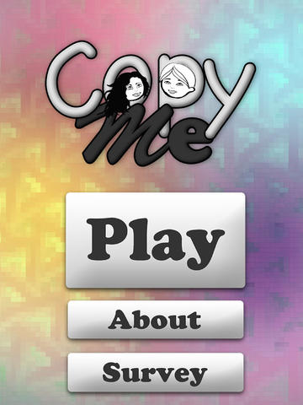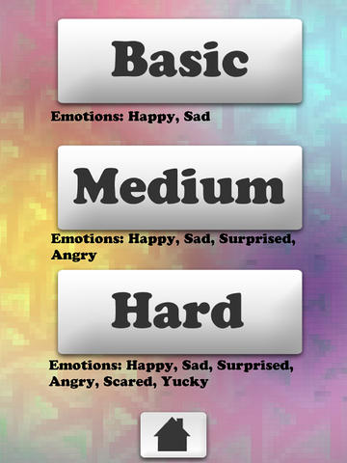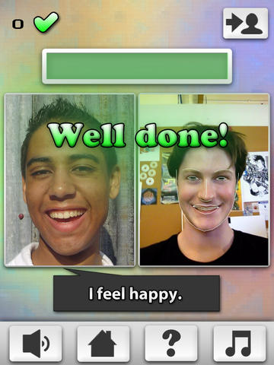

Emotional development is important in early childhood development. Early intervention is particularly crucial for people with psychological disorders such as those on the autism spectrum (ASD). Nevertheless, traditional interventions for emotional development are predominantly labour intensive and difficult to use for carers and parents.

This is why CopyMe was designed as an application (touch tablet) that uses game concepts and an innovative IT solution in order to provide an appealing experience and real time feedback.

The objective of the CopyMe game is to imitate facial expressions in photographs. It is currently designed for use on an Apple iPad and uses the tablet camera as the player's main introduction through the use of facial expressions. Throughout the game, the child may see visual indications superimposed on his or her own face on the screen when trying to imitate the expression required. The child is therefore able to obtain continuous feedback on how to make the expressions. The data is recorded for the purpose of health professionals' assessment of the child's behaviour.

JESTIMULE

Author(s): Gerip

Themes: multi-sensory stimulation

Presentation
The serious game "JeStimule" is an educational multi-sensory stimulation game for children with pervasive developmental disorders (PDD) or autism spectrum disorders (ASD).
It is a PC game that helps children recognise emotions expressed on faces and through gestures, as well as take a social context into account.
The objective of the JeStimule "serious game" is to learn social codes, and more specifically to recognise emotions. In order to learn, recognise and anticipate emotions, players will play in two phases:
- Learning: the player must learn to recognise emotions using a colour code;
- Experimentation: the player must recognise and anticipate emotions in a contextualised situation.
The objective of the learning phase is to enable the player to:
- Identify the emotion communicated by the body, gesture and face
- Name the emotion.
Different response modalities are based on:
- Colour codes
- Emotional words
- Idiomatic expressions
The 26 mini games offered make it possible to adapt the game to the players' skills, depending on whether or not they can read, as well as on their communication and socialisation skills.
The experimentation phase is the implementation of the learning stage using a 3D game platform. Depending on the situations that he or she encounters, the player must:
- Use the context in order to recognise and anticipate character emotions;
- Initiate appropriate requests;
- Choose actions based on communication gestures.
The purpose of this phase is also to assess the emotional expressiveness of the ASD child's avatar, by focusing on the expression of his or her own emotional feelings.
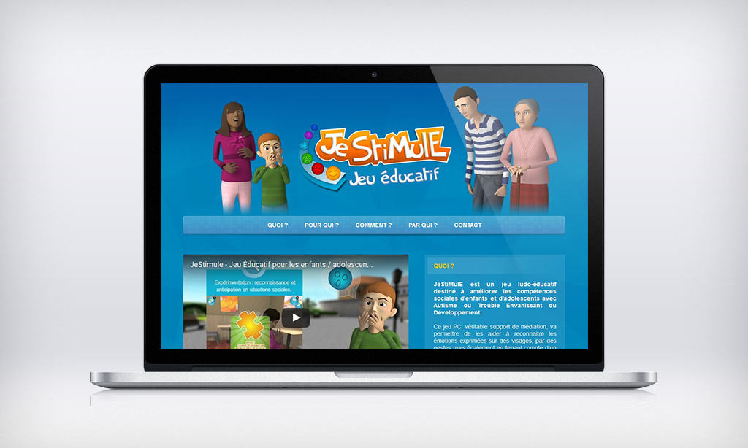

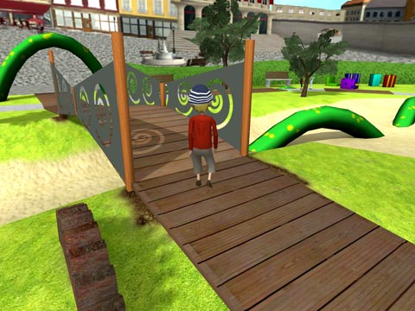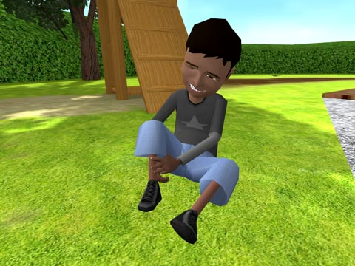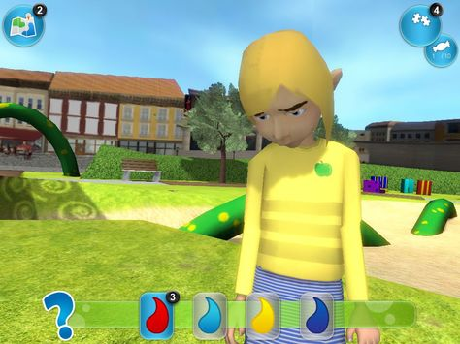

Technical description and characteristics
Year: 2011
Compatibility: Operating system: Windows XP, Vista, 7, 8, 8.1/Processor: AMD Athlon 3200+2 Ghz or Intel Pentium 4 2.8 Ghz/ RAM: 2 Go/ Graphics Card: ATI Radeon X1650 Series or Nvidia 8800 GT./ You must have a DVD player
Publisher: JESTIMULE was developed by Idées-3Com, in collaboration with the Autism Resource Centre of Nice, the CEA-List, HLP Technologies and the University of Nice Sophia Antipolis, with the support of the Ministry of the Economy, Industry and Employment, of CapDigital and Pôle Systematic.
The game was tested and approved by several partners, including GERIP.
Licence: Single or multi-computer licence
List price: From 129 euros.

Let’s Face It !

Author (s): The Outreach
Themes: Facial recognition of emotions

Characteristics
Compatibility: PC
License: free download: http://web.uvic.ca/~letsface/letsfaceit/
Year: 2010

Content

Let’s Face It!’ is a multimedia, computer-based intervention that is designed to teach face processing skills to children with autism. Research has shown that children with autism experience difficulties in their ability to recognize facial identity and emotions. The main purpose of the intervention is to support children with Autism in improving their ability to recognize facial identity and emotions. The program includes 7 different interactive computer games that target the specific face impairments associated with Autism. They also include the recognition of identity across image changes in expression and face processing strategies. To investigate the effectiveness of the program a randomized controlled clinical trial was designed. The study recruited 42 children with Autism spectrum disorders. In a first stage the children were screened examining their face and object processing abilities. The children, who were randomly assigned to the treatment group, received 20 hours of face training with the ‘Let’s Face It!’ Intervention, where children assigned to the control group did not. The results showed that children in the treatment group demonstrated significantly improvements in their analytic recognition (p <0.05) and holistic recognition (p>0.001) of daces, compared to children in the control group.

Conclusion

Children with an Autism Spectrum Disorder can improve their face recognition skills in a relatively short period, when
they play the different games included in the ‘Let’s Face It!’ program.

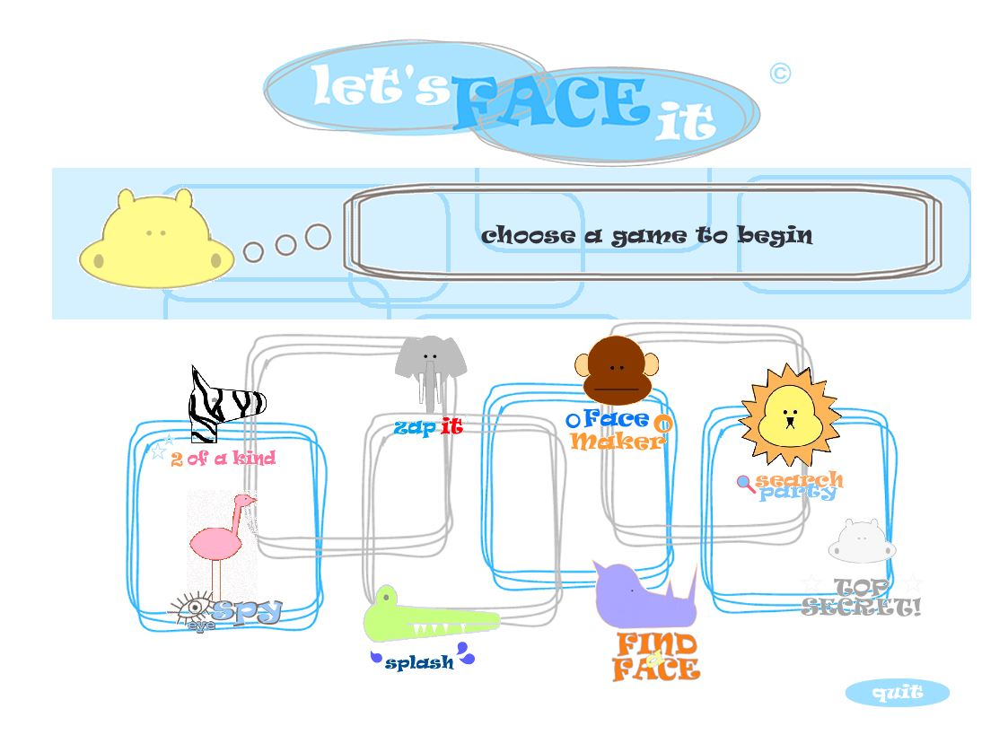

Choix des jeux
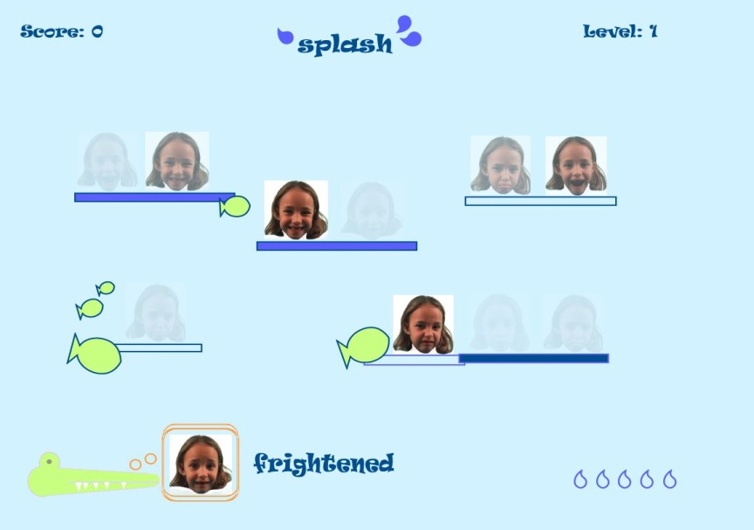
« Splash »

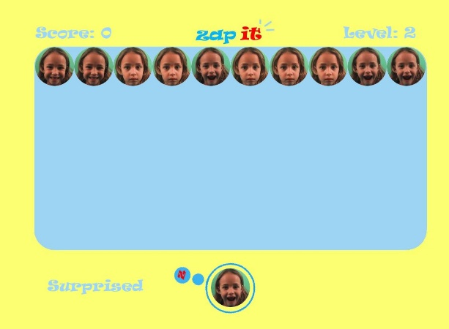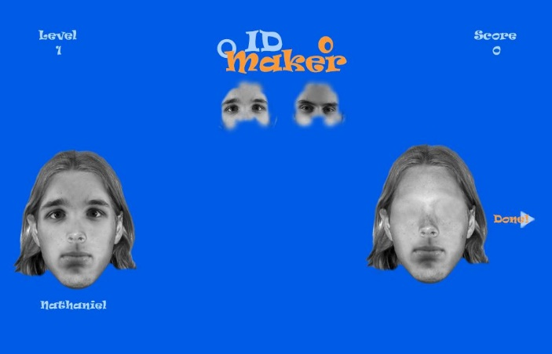
« Zap it » « Face Maker »

LifeIsGame (Learning Facial Emotions Using Serious Games)

Author (s): University of Porto, University of Austin

Theme: emotions

Presentation

The ability of socially and emotionally impaired individuals to recognize and respond to emotions conveyed by the face is critical to improve their communication skills.

The LIFEisGAME project attempts to show how it is possible to apply a pioneer serious game approach to teach people with Autism Spectrum Disorder (ASD) to recognize facial emotions, using real time synthesis and automatic facial expression analysis..

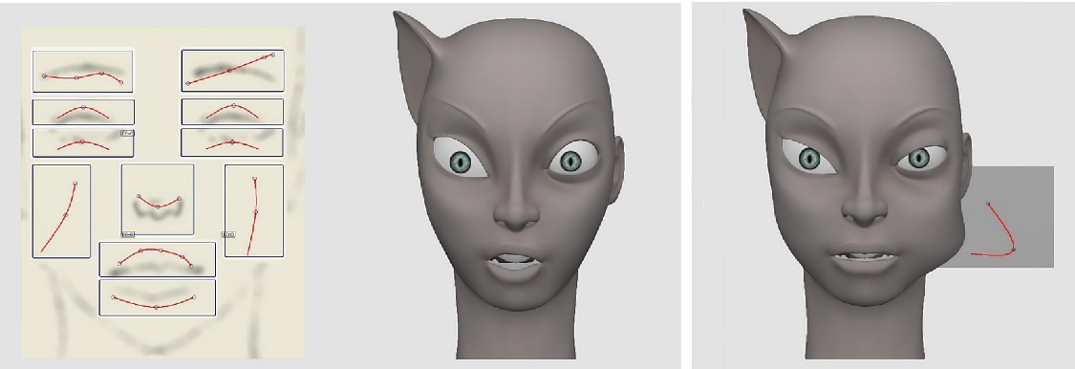

The Platform
Accurate recognition and interpretation of the facial expressions help individuals decide when
to make socially acceptable statements and provide guidance in determining approach or
withdrawal strategies in personal interactions.
When creating a videogame to help children with ASD to understand the world of emotions,
we need to build it in a way that motivates and takes into account the individuality of each
child.

The therapist can adapt each session in order to control the environment according to child's
characteristics, the selected platform and the game mode, and thus combine the settings
available to achieve different learning outcomes.

Game Modes

- Recon Mee

Encourages the children to watch a sequence of random facial expressions and recognize the emotion. They learn by identifying the specific expression and actively experiment with different possibilities of detecting the desired facial expression.

- Sketch Mee

The children build facial expressions on a 3D character to match defined emotions, by drawing strokes on the 3D avatar or moving facial features, such as the corner of the mouth, nose or eyebrows.

- Mimic Mee

The children learn how to recognize and identify facial expressions by mimicking facial expressions on the 3D avatar, like if they were playing with a mirror.

- Play Mee

The children are presented with a story and are expected to perform the expression correspondent to the situation depicted in the story. They can experiment how to portray emotions according to each situation.
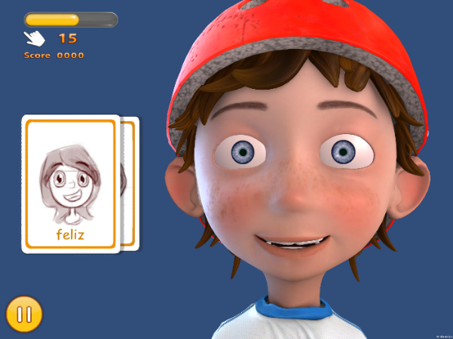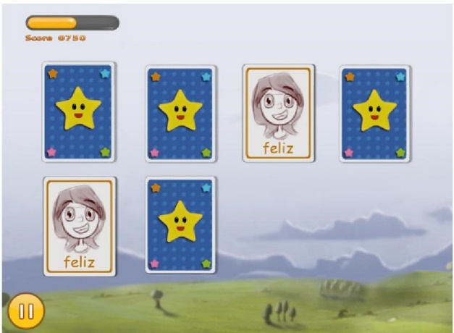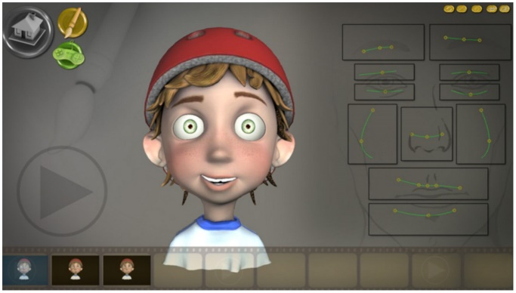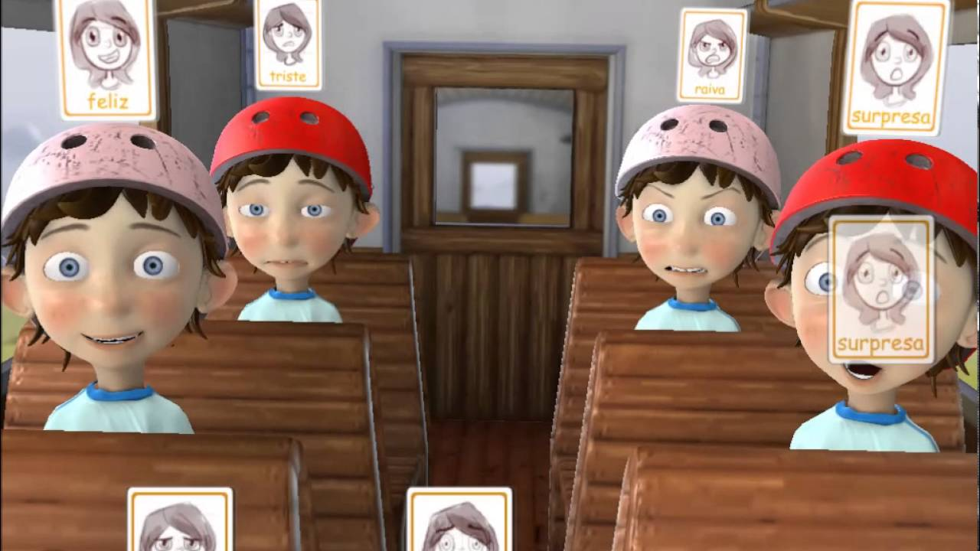

MIND READING

Author (s): Simon Baron-Cohen

Themes: facial expression, emotion recognition

Presentation

Mind Reading is a unique reference work covering the entire spectrum of human emotions. Using the software you can explore over 400 emotions, seeing and hearing each one performed by six different people.

Mind Reading is for everyone interested in emotions. It has been designed with awareness of the special needs of children and adults who have difficulties recognising emotional expression in others. It is also an invaluable resource for actors, directors, writers and anyone involved in the dramatic arts. The title enables the user to study emotions and to learn the meanings of facial expressions and tone of voice, drawing on a comprehensive underlying audio-visual and text database.

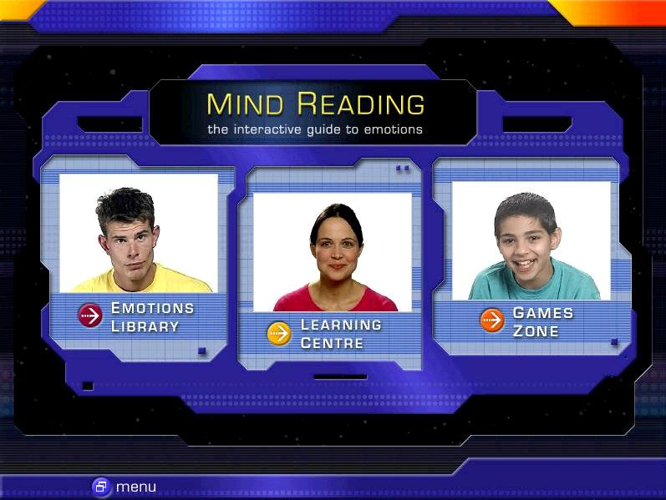

The game contains three parts:

- Emotions Library
Here you can study 412 different emotions organised into 24 related groups. Six video clips are provided for each emotion showing close-up performances by a wide range of people (old, young, men, women, boys, girls, etc).

Six audio clips are also provided with the chosen emotion being expressed in the appropriate tone of voice. There are written definitions, synonyms, notes, a search facility and a scrapbook where you create and organise your own collections.

The Emotions Library is also available to purchase separately.

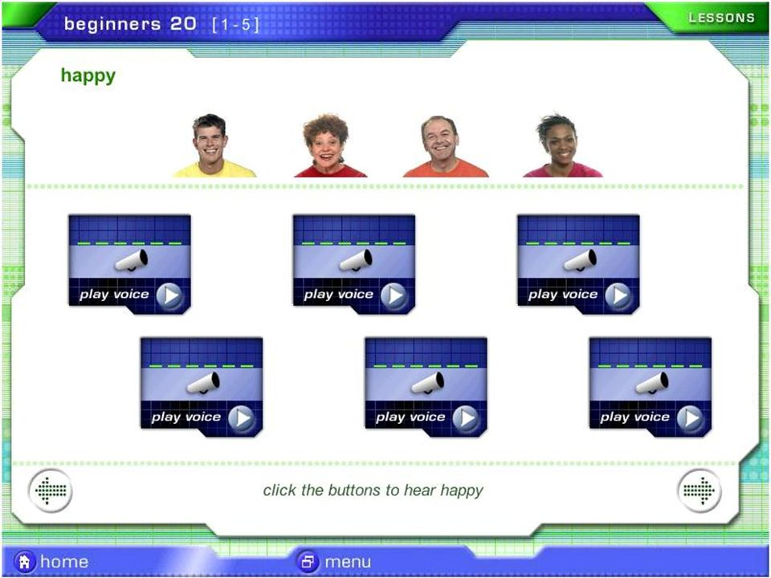

- Learning Centre
This area of the product is intended to help people who have difficulty recognising emotions. It has been designed particularly with the needs of those with autism spectrum disorders and Asperger Syndrome in mind.

A variety of lessons and quizzes are provided to present emotions in a systematic way and then to test recognition. The difficulty of the lessons can be adjusted to suit a wide range of ages and ability levels.

A rich set of collectible rewards is provided to help motivate students.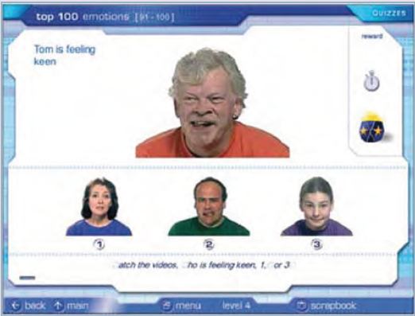

- Games Zone
If you just want to have fun with emotions, then play one of the games in this section of the product. See how world famous actor Daniel Radcliffe reacts to being offered some raw squid! Visit a school, an office or a market to guess how the people there are feeling. Play a fast moving card game where you have to match the faces to win.

The games zone encourages informal learning about emotions in a less structured setting.

SMILEMAZE

Theme: expression recognition

Presentation
This video game incorporates the same Computer Expression Recognition Toolbox as the Let's Face It! game.

The objective is to navigate a Pac-Man labyrinth by avoiding obstacles and collecting the most sweets as possible. The player controls a PacMan-type avatar using the keyboard to navigate (up, down, left, right). The player uses facial expressions to move the avatar from obstacles to various points within the labyrinth and must produce and maintain the emotion requested (smile, anger or surprise) in order to unlock the passage and continue on its way.

This video game was designed by researchers in order to help autistic children to practice emotions. The idea is to maintain the emotion for a sufficient amount of time to fill a "smile-o-meter".

The system makes it possible to recognise faces and judge these expressions in real time, on the basis of 8,000 pre-programmed examples. If the smile deviates from the game requirement, for example, the smile-o-meter stops.

In the study, 17 children with autism and 23 witnesses all aged 6 to 18, played three levels each of the "smile" mode and the "anger" mode. The facial expressions of participants were recorded beforehand.

Informal field tests indicate that children with ASD like to play SmileMaze because they find the game naturally entertaining and fun, therefore encouraging spontaneous smiling expressions during the game. SmileMaze demonstrates the link between voluntary and involuntary expressions in a game format where voluntary productions may lead to involuntary productions and changes in emotional state.
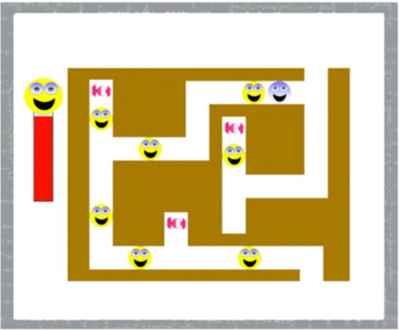

This document was drafted in the context of the "e-Goliah" applied research project led by Genious Systèmes, in partnership with CRAIF and the Child and Adolescent Psychiatry Unit of the CHU Pitié Salpêtrière. This research was funded under Theme 3 of the Autism and New Technologies programme supported by the UEFA Foundation for Childhood and the Orange Foundation.

The objective of this documentary file is to assess current applied research on serious games for autism and to present several of the games that have been clinically tested.

